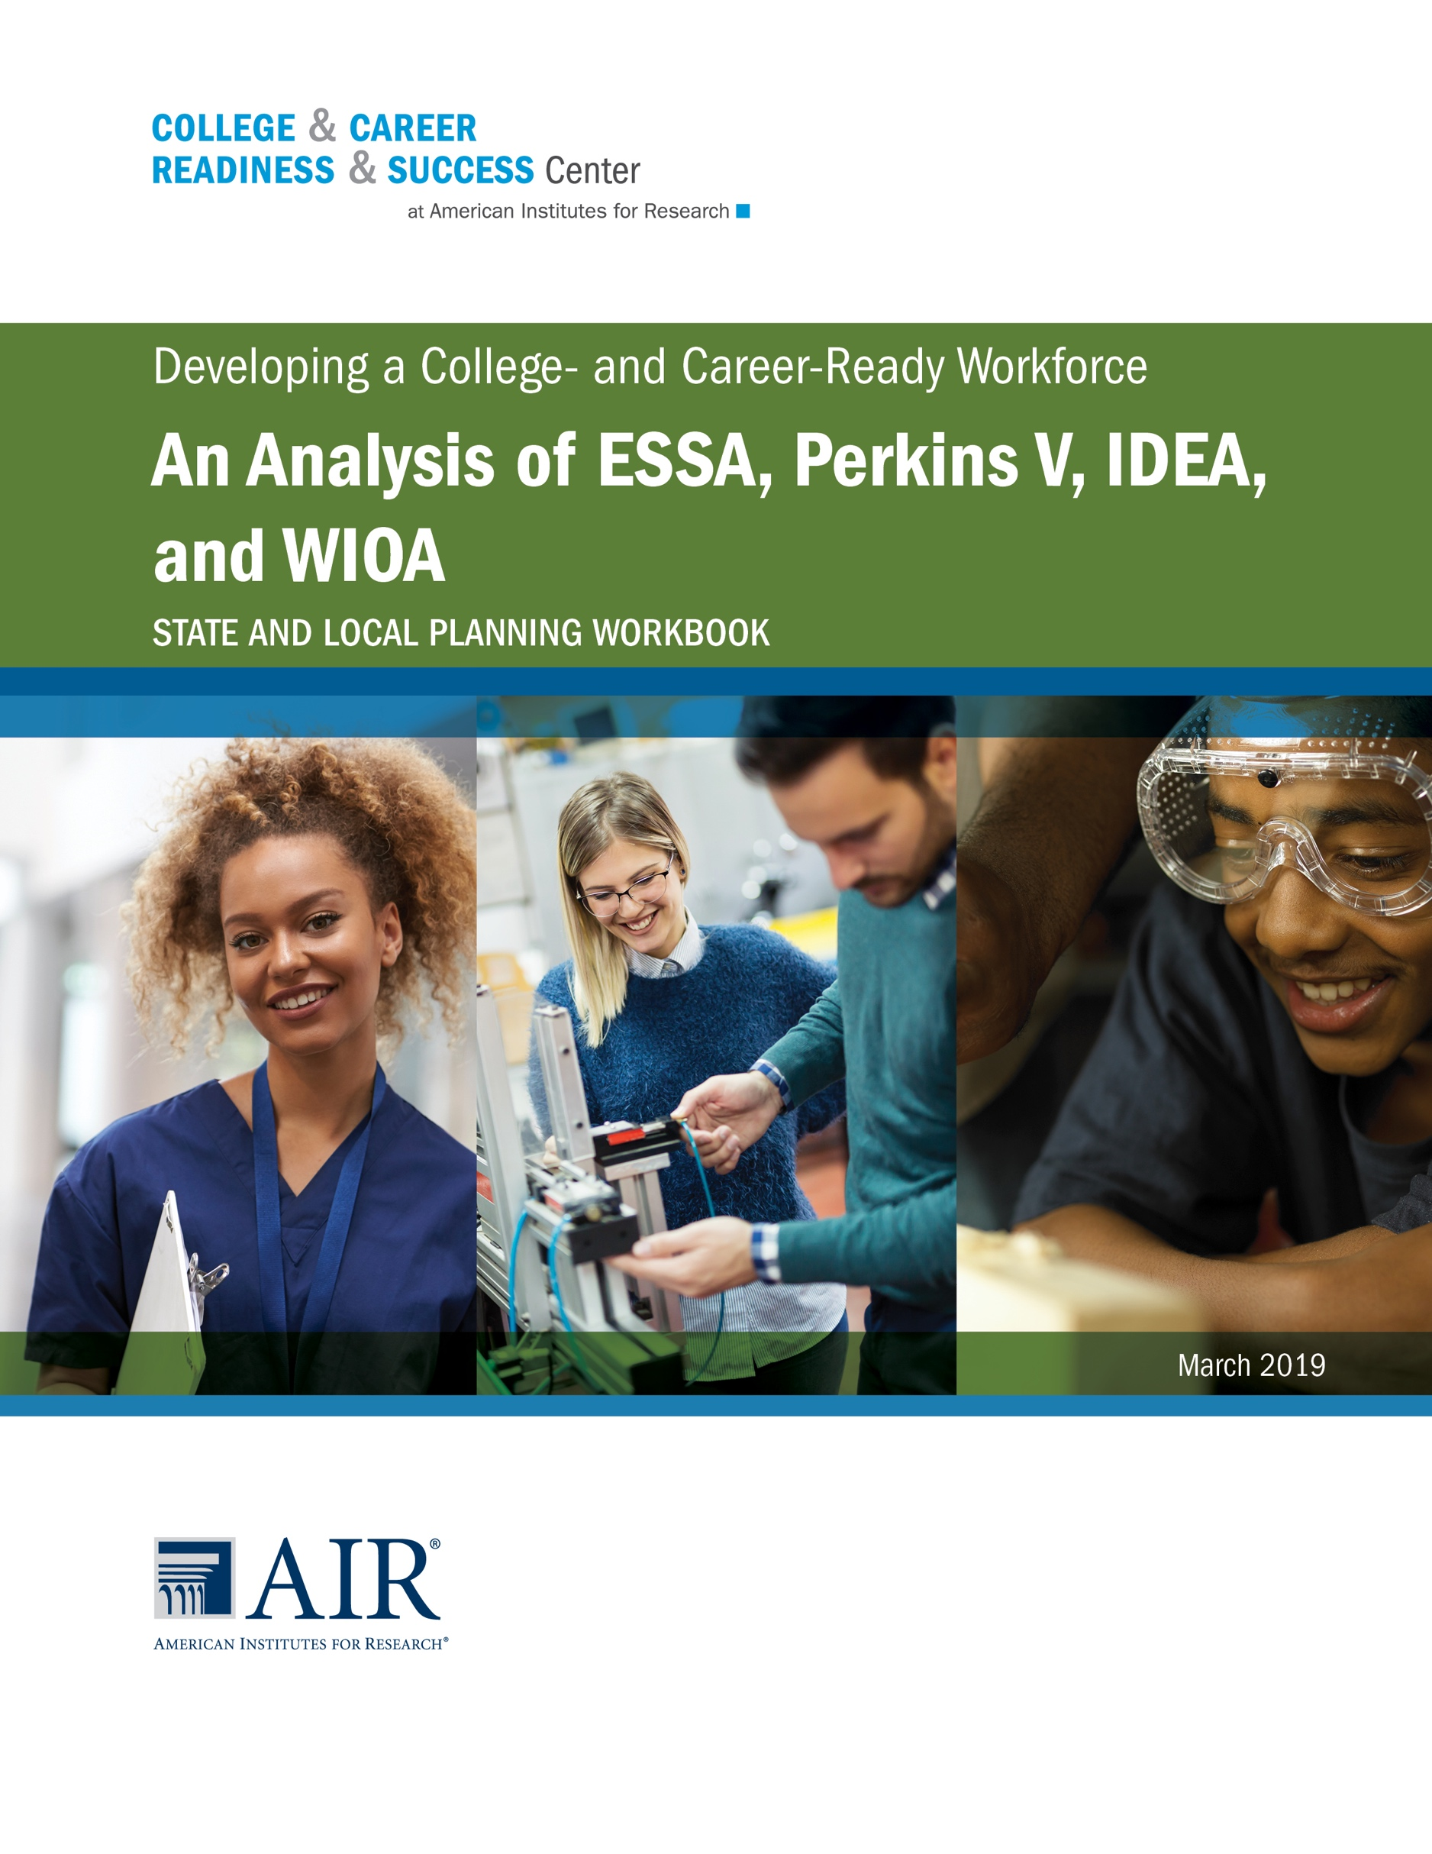

State and Local Planning Workbook
Purpose: This workbook is intended to facilitate conversations with state teams to identify and plan for opportunities to align college and career readiness efforts across ESSA, Perkins V, IDEA, and WIOA. State teams should include representatives who are familiar with the state’s plans for each of the four laws, can speak to the implementation details, and have authority to act on collaborative opportunities identified.
Directions: Stakeholders familiar with each of the four laws respond to each of the guiding questions. As stakeholders respond to the questions, identify opportunities in the plans or existing implementation practices that may be applicable to the other laws. In addition to identifying opportunities for alignment, define key terms for the laws. This could include terms that are crucial for developing understanding or terms that have different definitions or connotations between the laws. Finally, consider any key stakeholder groups that need to be engaged to facilitate alignment across the laws.
Preparation: Prior to convening as a large group, all stakeholders should review the guiding questions and be prepared to respond. Furthermore, stakeholders should consider areas that are strongest within their laws, as well as areas that are an existing challenge or areas where they want support from the other laws. Guiding questions to be prepared in advance include:
- Question 1: How does the plan define the academic, technical, and employability skills that learners must know and be able to do to be college and career ready?
- Map your state’s current education-to-workforce pipeline and indicate how each of the four laws interact throughout a student’s trajectory.
- Identify the college and career readiness vision articulated by each plan, including how the plans define success for students.
- Categorize the academic, technical, and employability skills—as articulated in each of the plans—that are necessary for college and career readiness.
- Question 2: How does the plan define when learners are meeting the academic, technical, and employability skills expectations for college and career readiness?
- Identify the accountability measures that reflect the academic, technical, and employability skills that are necessary for college and career readiness.
- Identify the assessments used to assess the academic, technical, and employability skills that are necessary for college and career readiness.
- Review data reporting requirements for the law and identify opportunities to share data in a coherent state longitudinal data system.
- Question 3: What are the non-learner structures and resources needed (fiscal, human capital, programmatic, and community)?
- Which funding streams are used to support the development of student academic, technical, and employability skills?
- Describe how the plan identifies and responds to the academic, technical, and employability skills technical assistance content and pedagogical needs of educators.
- Identify the coordinating community organizations, throughout the PK–20 continuum, that support the development of academic, technical, and employability skills for all learners.

- Question 4: What guidance and services should be provided to develop college and career readiness among individual learners?
- List the academic and non-academic supports that personalize college and career readiness development in learners. Supports should reflect individual learner’s interests, skills, needs, and goals.
- Identify existing strategies or opportunities to integrate academic, technical, and employability skills into K–12 standards, curricula, and instructional practices.
- Review work-based learning policies, practices, and processes and identify successful practices that can be scaled or replicated. If none exist, skip.

Question 1: How does the plan define the academic, technical, and employability skills that learners must know and be able to do to be college and career ready?

 | ESSA Plan and Implementation Efforts | Perkins V Plan and Implementation Efforts | IDEA Plan and Implementation Efforts | WIOA and Implementation Efforts
Map your state’s current education-to-workforce pipeline and indicate how each of the four laws interact throughout a student’s trajectory.
Identify the college and career readiness vision articulated by each plan, including how the plans define success for students.
Categorize the academic, technical, and employability skills—as articulated in each of the plans—that are necessary for college and career readiness.

Opportunities to reference, leverage, or build on state ESSA, Perkins V, IDEA, and WIOA plans and practices: |  | Key Terms to Define:
 |  | Key Stakeholders to Engage:

Question 2: How does the plan define when learners are meeting the academic, technical, and employability skills expectations for college and career readiness?

 | ESSA Plan and Implementation Efforts | Perkins V Plan and Implementation Efforts | IDEA Plan and Implementation Efforts | WIOA and Implementation Efforts
Identify the accountability measures that reflect the academic, technical, and employability skills that are necessary for college and career readiness.
Identify the assessments used to assess the academic, technical, and employability skills that are necessary for college and career readiness.
Review data reporting requirements for the law and identify opportunities to share data in a coherent state longitudinal data system.

Opportunities to reference, leverage, or build on state ESSA, Perkins V, IDEA, and WIOA plans and practices: |  | Key Terms to Define:
 |  | Key Stakeholders to Engage:

Question 3: What are the non-learner structures and resources needed (fiscal, human capital, programmatic, and community)?
 | ESSA Plan and Implementation Efforts | Perkins V Plan and Implementation Efforts | IDEA Plan and Implementation Efforts | WIOA and Implementation Efforts
Which funding streams are used to support the development of student academic, technical and employability skills?
Describe how the plan identifies and responds to the academic, technical, and employability skills technical assistance content and pedagogical needs of educators.
Identify the coordinating community organizations, throughout the PK–20 continuum, that support the development of academic, technical, and employability skills for all learners.

Opportunities to reference, leverage, or build on state ESSA, Perkins V, IDEA, and WIOA plans and practices: |  | Key Terms to Define:
 |  | Key Stakeholders to Engage:

Question 4: What guidance and services should be provided to develop college and career readiness among individual learners?

 | ESSA Plan and Implementation Efforts | Perkins V Plan and Implementation Efforts | IDEA Plan and Implementation Efforts | WIOA and Implementation Efforts
List the academic and non-academic supports that personalize college and career readiness development in learners. Supports should reflect individual learner’s interests, skills, needs, and goals.
Identify existing strategies or opportunities to integrate academic, technical, and employability skills into K–12 standards, curricula, and instructional practices.
Review work-based learning policies, practices, and processes and identify successful practices that can be scaled or replicated. If none exist, skip.

Opportunities to reference, leverage, or build on state ESSA, Perkins V, IDEA, and WIOA plans and practices: |  | Key Terms to Define:
 |  | Key Stakeholders to Engage:

